Video 25 — Long-Term Memory in LangGraph
CampusX Agentic AI using LangGraph · Playlist position 25 · Theory-first study notes
Watch the lesson · Full playlist
Study scope: Important conceptual material and small teaching examples, not a recreation of the tutorial project. These are original explanatory notes based on the video’s public chapter outline and the linked technical sources—not a transcript.
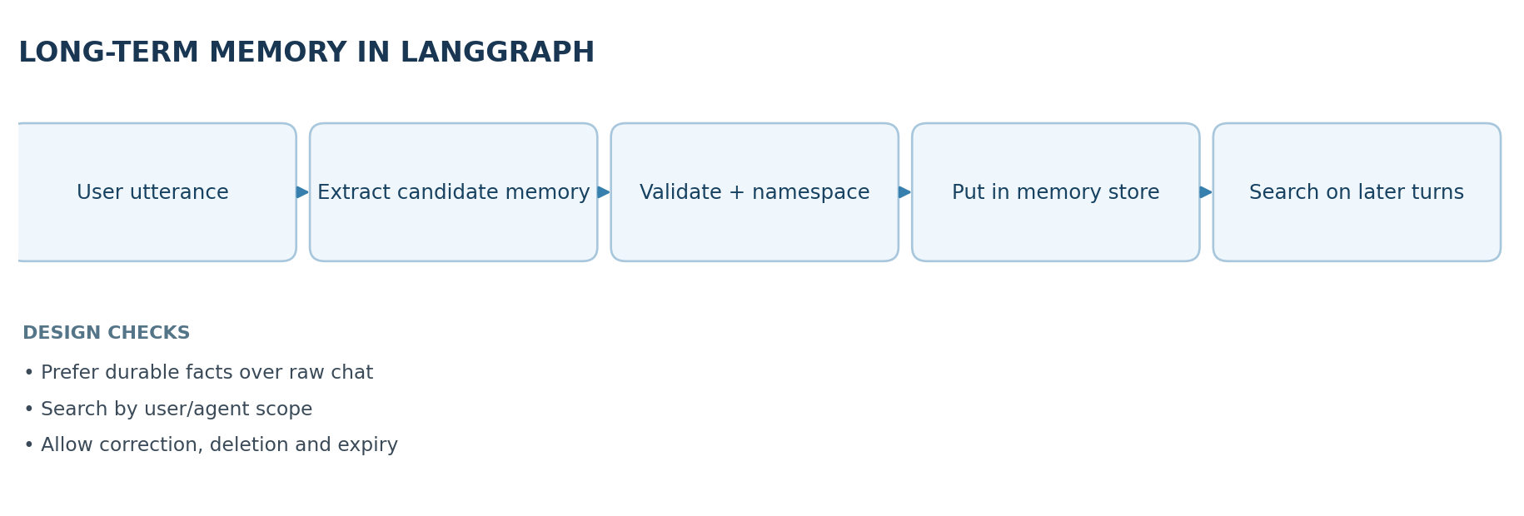

Learning objectives
Distinguish long-term memory from per-thread checkpointing, explain LangGraph's store abstraction, design namespaces and keys for safe retrieval, and reason about when an agent should write, search, update or delete reusable knowledge.

1. Defining long-term memory
Short-term context answers, “What was said in this thread?” Long-term memory answers, “What useful fact, event or reusable instruction should still be available later—even in another thread?” The application extracts and persists selected information separately from the model's short-lived prompt.
Examples: preferred programming language, repeated formatting constraints, the outcome of a previous deployment, a reusable troubleshooting strategy. Long-term memory should be selective, not an uncontrolled copy of every chat line.

2. LangGraph stores versus checkpointers
Concern | Checkpointer | Store
Primary scope | One graph execution or conversation thread | Across threads, users or workflows as configured
Typical content | Messages and intermediate graph state | Facts, notes, episodes, procedures
Common lookup | thread_id | Namespace + key, and optional semantic search
Lifecycle | Snapshots during execution | Explicitly written, read, updated and removed items
In LangGraph, a store exposes operations such as put, get, search and delete (depending on backend), and a graph can be compiled with a store so nodes can access it. Storage scope comes from your chosen namespace; it does not enforce identity policy automatically.

3. Memory types, with examples
- Semantic: stable facts. “Prefers concise Python examples.” Good for personalization if explicitly provided and still relevant.
- Episodic: experiences or outcomes. “The last pipeline run failed because the credentials had expired.” Good for troubleshooting and continuity.
- Procedural: preferred steps. “When deploying, run tests then request review.” Good for repeatable agent behavior.
Do not overfit human memory terminology to a database. The design question is what data to keep, at what scope and how to retrieve it safely.

4. Namespace design: who can see this memory?
A namespace might be a tuple such as ("users", user_id, "preferences") or ("teams", team_id, "deployment_lessons"). A separate key identifies a specific record. The app must verify that the caller is allowed to access the namespace before search or retrieval; never trust a user-supplied identity string by itself.

Minimal LangGraph store example
from langgraph.store.memory import InMemoryStore
store = InMemoryStore()
namespace = ("users", "user_42", "preferences")
store.put(namespace, "preferred_language", {"language": "Python"})
item = store.get(namespace, "preferred_language")
print(item.value)
# Reading another namespace requires application authorization.
for item in store.search(namespace):
print(item.key, item.value)
This works as a conceptual synchronous in-memory example. It does not survive restart. A production store should be persistent, access-controlled and configured for any semantic-search indexing you actually need. Plain key lookup and semantic search are different capabilities.

5. Memory write path: what deserves storage?
A good system should first classify candidate information:
- Usefulness: will it matter again?
- Reliability: was it explicitly stated, independently verified, or merely guessed by the model?
- Sensitivity: is it necessary and appropriate to store? Does user consent or policy allow it?
- Scope and duration: one thread, one user, shared team, or temporary task?
- Conflict check: does an existing memory contradict the candidate?
- Update operation: create a new record, correct an old one, or discard the candidate.
Bad pattern: store every inferred preference as permanent fact. Better pattern: persist explicit durable preferences and provide a correction/deletion path.

6. Memory read path: relevant recall
At the beginning of a new request, the agent determines whether past facts are useful. It then searches within an authorized namespace, possibly using keywords or vector similarity, retrieves a small number of records, filters them for relevance and freshness, and constructs a concise prompt with the selected facts.
Example: if the user asks about a bug in a Python dependency, recall a saved preference for Python and a recent incident involving that dependency—not unrelated travel plans. This controls token cost and minimizes accidental disclosure.

7. Semantic indexing and retrieval
A vector-enabled store may embed the searchable text of memory records and retrieve candidates whose meanings are related to the query. Embedding similarity is a candidate ranking signal, not proof that a memory is true, current or allowed. Metadata filters, exact-key lookups and per-user namespaces often matter just as much as vector similarity.
Trade-offs: a very small number of detailed records is easy to reason about but may omit nuance; thousands of tiny memories improve granularity but increase duplicate detection, retrieval complexity and maintenance work.

8. Lifecycle, security and evaluation
- Provide mechanisms to inspect, edit, forget and expire saved memories.
- Remove secrets, credentials and regulated information from candidate storage unless explicitly supported and authorized.
- Test “not found” behavior; an agent should ask or abstain rather than inventing a past preference.
- Audit cross-user data isolation and permission boundaries.
- Measure memory precision (recalled facts are correct), recall (needed facts are found) and useful personalization (output improves).
- Preserve the source/provenance and last-updated timestamp where possible to resolve conflicts.

9. Quick revision
Checkpointers preserve an execution's state. Long-term stores preserve selected knowledge. The system needs well-defined write rules, read rules, identity boundaries and lifecycle controls for either mechanism to be trustworthy.

Self-check questions
- Why isn't a persistent checkpoint automatically a long-term user preference memory?
- What is a namespace used for, and why doesn't it replace authorization?
- How do exact-key search and semantic search differ?
- Should a single one-off request always be stored as a durable preference?
Suggested answers: (1) checkpoints track one thread and do not imply cross-thread fact extraction; (2) logical grouping but caller permissions are separate; (3) direct identifier lookup versus ranked similarity; (4) no—only when useful, reliable and appropriate.

Visual recap
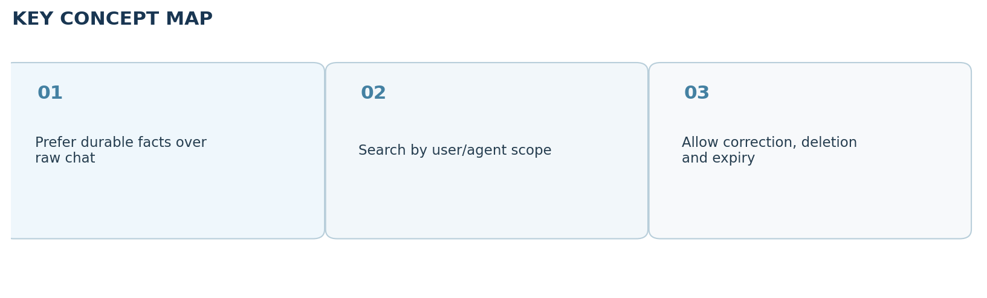

Clickable video chapters
- Watch the full video (Long-Term Memory in LangGraph) — no independently verified chapter timestamps were available, so none are invented.

References and further reading
- CampusX video
- Long-term memory guide
Prepared October 2026. Figures are original study diagrams, not screenshots or official CampusX illustrations. Some APIs may change; consult the linked official references before production use.

